**Welcome to**

**Moorlands Junior School**

**Breakfast & After School Club**

**Information & administration pack for parents & children**

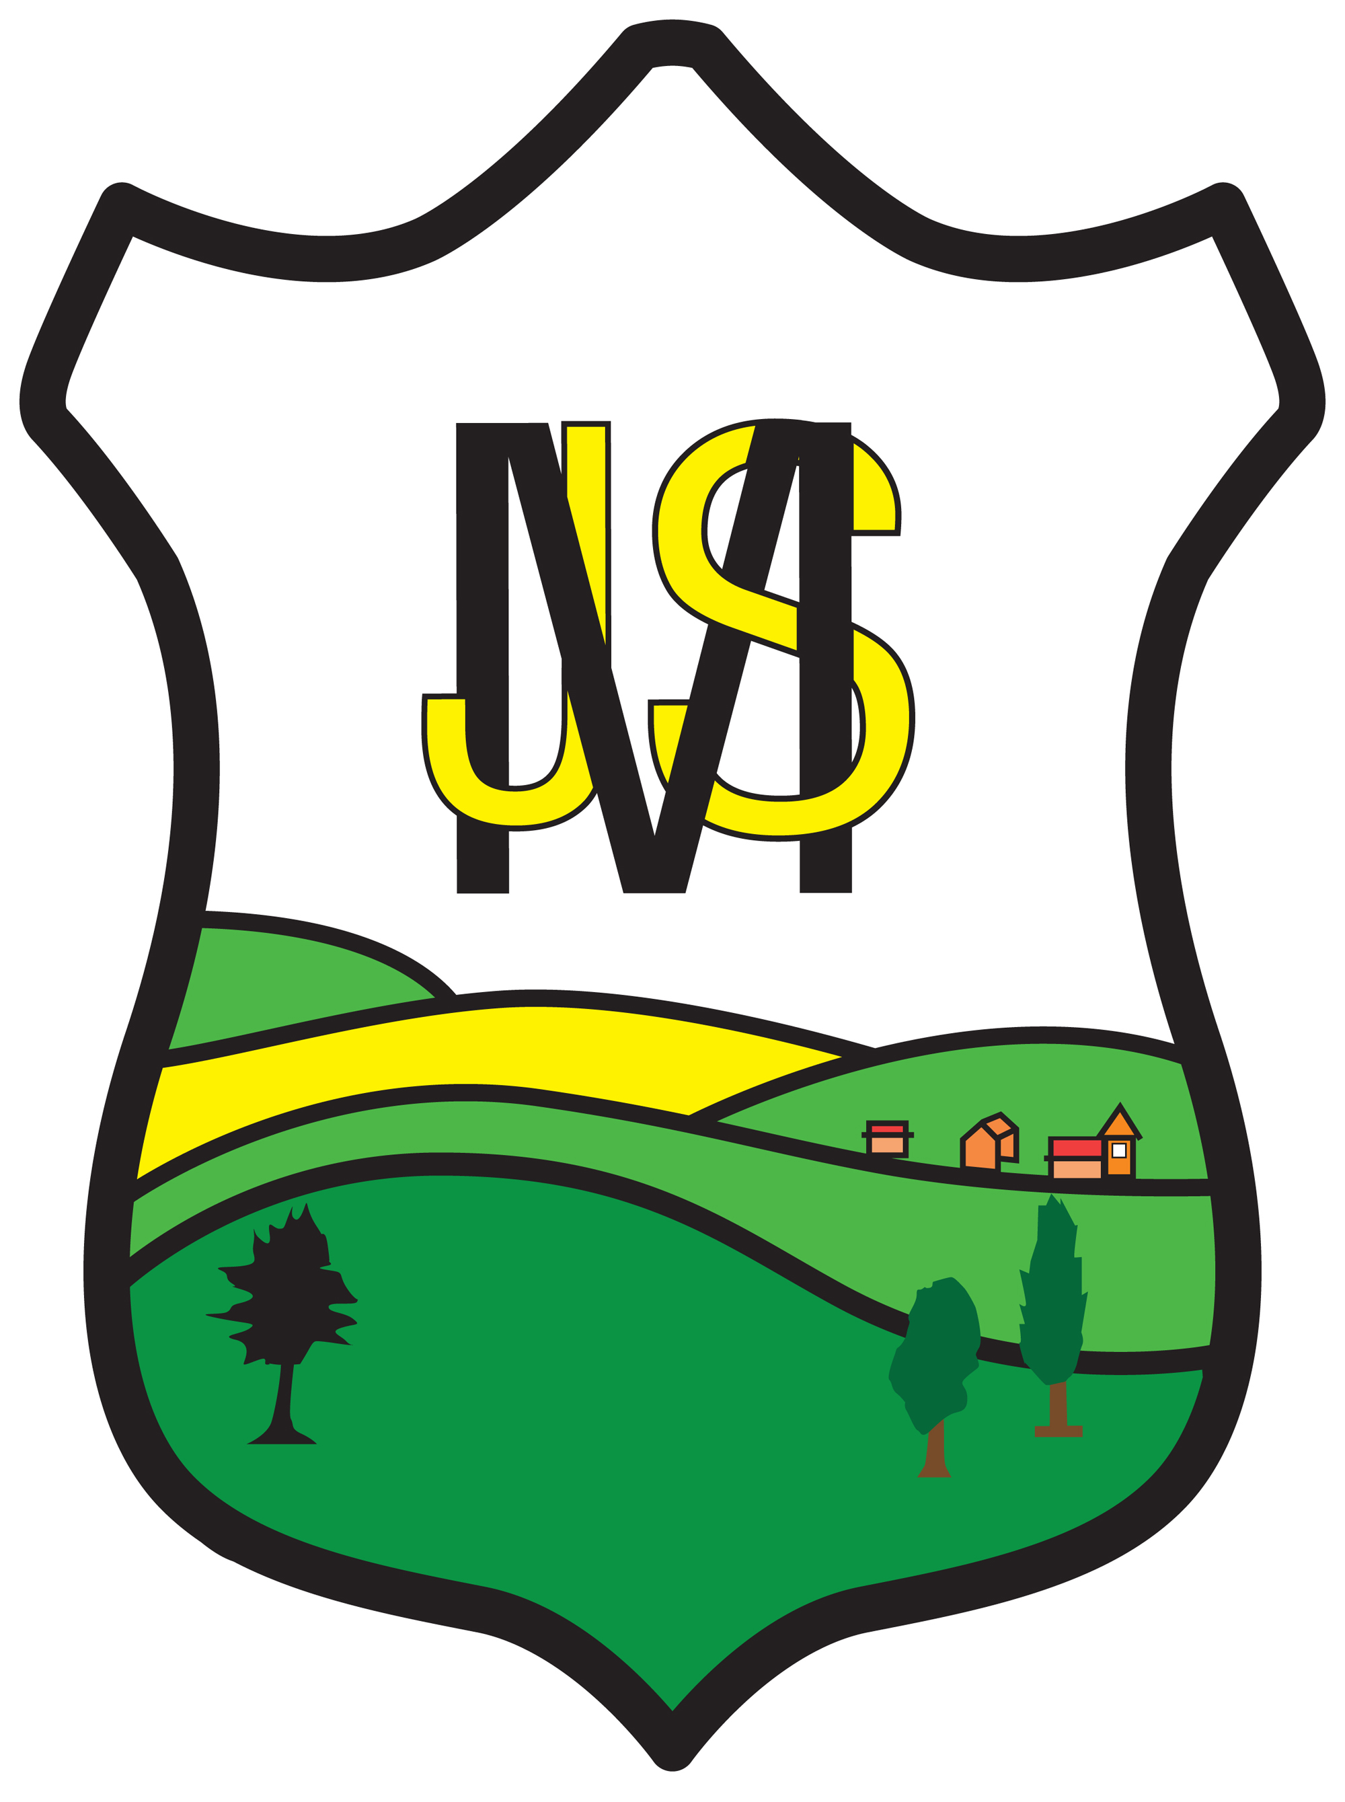

**Child’s Name……………………… Class……..**

**Details of Child**

|  |  |  |  |  |
| --- | --- | --- | --- | --- |
| Surname | | | Forename | |
| Middle Name | | | Chosen Name | |
| Gender Male Female | | | Date of Birth | |
| Admission Date | | |  | |
| Year Group | | | Class | |
| Address | | | | |
| Post Code | | | | |
| Telephone No. | | | Mobile No. | |
| **Parent/carer details** | | | | |
|  | **Name** | **Home Address** | | **Day Address** |
| **Parent/ Carer**  **1st contact** | Relationship: | Phone No:  Mobile No:  Email: | | Phone No:  Mobile No: |
| **Parent/ Carer 2nd contact** | Relationship: | Phone No:  Mobile No:  Email: | | Phone No:  Mobile No: |

**Additional named person authorised to collect your child**

Name

Phone number(s)

Relationship to child

**Sessions required (please tick) Required Start Date……………………….**

|  |  |  |  |  |  |
| --- | --- | --- | --- | --- | --- |
|  | Monday | Tuesday | Wednesday | Thursday | Friday |
| Breakfast Club |  |  |  |  |  |
| After School club |  |  |  |  |  |
| Ad Hoc Sessions |  |  |  |  |  |

**Ad hoc sessions are now available**

**Please email** [**munchkidz@moorlandsjuniorschool.com**](mailto:munchkidz@moorlandsjuniorschool.com) **as soon as you know what session(s) you require.**

**Please let us know ASAP if you need to change your sessions.**

**Medical & Dietary Information**

|  |  |  |
| --- | --- | --- |
| Doctor |  | |
| Address |  | |
| Telephone |  | |
| Medical Information / Disability / Special Needs | | |
| Asthma 🞎 ⁪  Diabetes 🞎 ⁪  Eczema 🞎 | | Epilepsy 🞎 ⁪  None 🞎 ⁪ ⁪ |
| Other (Please Specify) | | |

**Please note if Medication is to be administered by us, a separate ‘Administration of Medication Consent Form’ will need to be completed this can be obtained from the school office.**

**Details of Dietary requirements and Allergies**

**Please specify in the box below if your child has any allergies:**

|  |  |
| --- | --- |
| Artificial colouring 🞎 ⁪  Gluten free 🞎 ⁪  Halal 🞎 Kosher food only 🞎 ⁪  No dairy products 🞎 ⁪ | No nuts of any type 🞎 ⁪  No pork 🞎 ⁪  Seafood allergy 🞎 ⁪  Vegetarian 🞎 ⁪ |
| Other please specify:  Allergy should be medically diagnosed not just a food preference. | |

**Consent Form**

**YES NO**

|  |  |  |
| --- | --- | --- |
| **I give consent to my child’s work being displayed and labelled with their name at the club.** |  |  |
| **I give consent for photographs to be taken for possible use in student portfolios, publicity, including our web site and display within the club (no names are used).** |  |  |
| **I give consent for my child to have their face painted if they wish when this activity is arranged.** |  |  |
| **I give consent for my child to have party food on special occasions.** |  |  |
| **I give consent for basic First Aid to be carried out by trained First Aiders which includes the use of Hypo-allergic plasters.** |  |  |
| **I give consent to seek any necessary emergency medical advice or treatment in the future.** |  |  |
| **I give consent for medication to be administered with relevant consents given prior to administering.** |  |  |
| **I give consent for my child to be transported to hospital in an emergency and receive emergency treatment in hospital. ( the child’s Parent/ Carer would always be contacted in such cases.)** |  |  |

**Parent/ Carer’s signature**

**I have legal responsibility for the above named child. I have read and accept the Terms & Conditions of Moorlands Breakfast and Afterschool Club.**

**Signed………………………..Printed………………………………Dated……………….**